Weebly for Education is Perfect for You and Your Students Weebly is perfect for creating classroom websites, student e-portfolios, and websites for assigned projects. Our drag & drop website editor is stunningly simple to use, and appropriate for use with students of all ages. Weebly enables your students to express themselves creatively using a variety of multimedia features, all within a protected environment that you control. Weebly was named one of TIME's 50 Best Websites of the year, and here's why:

Easy, Drag & Drop Website Editor
Our core advantage is our stunningly easy drag & drop website editor. Videos, pictures, maps, and text are added by simply dragging them to your website. We love it when new customers are totally surprised at how straightforward it is to build a website with Weebly – no HTML or technical skills required!

A Managed, Protected Environment for Your Students
With Weebly, you can password protect all your students' websites with one click. We understand that privacy is extremely important to teachers, students, and parents. You have full control over which websites are public, which are private, and which can be edited by the student. It's simple to bulk create new student accounts and oversee your students' activity.

Powerful Multimedia Features
If you can imagine it, you can do it with Weebly. Add pictures, videos, audio players, documents, maps, and photo galleries easily by dragging and dropping. Use Weebly's unbranded audio and video players so that you and your students do not need to venture out to YouTube or similar services to add high quality audio & video to your sites.

Flexible Blogging Features
Post class updates, homework assignments, and news for parents using our super slick blogging features. Blogs are also great for students to express their thoughts and receive comments from others. Weebly supports an unlimited number of blogs within your website, with full comment moderation features allowing an open, moderated, or closed conversation.

It’s Free
It is completely free to create and publish a website with Weebly. Our service has always been, and always will be free. So, how is Weebly supported? Weebly has optional Pro account features for just $39.95 per year, and we offer add-on packs of student accounts (10 accounts for $10) if your needs exceed the 40 accounts that are included. That's it! We've heavily discounted our education services; should you choose to upgrade, we really appreciate your support!

No Advertising
We don't place advertising on your site, and never will. Some "free" website providers force advertising to be placed on your site, but you don't need to worry about that with Weebly.

70+ Beautiful Designs (or Customize Your Own)
Deciding on a look for your website couldn't be easier. We have dozens of beautiful designs to choose from and add more regularly. Want to bring your own? You can completely customize the template of your site, or build your own with HTML & CSS, right in the Weebly editor.

Hosting Included – No Restrictions
We provide the hosting so you don’t need to pay for a hosting provider. We don’t impose arbitrary bandwidth restrictions, storage caps or limits on the number of pages allowed, either. The Weebly service is fully available online, so there is nothing for you to install or configure. Our hosting infrastructure is backed by an army of servers that provide reliable stability for your websites – all for free!

Publish to Your Own Domain
If you already own your own domain, use it with Weebly, at no charge. You can publish to your own domain name (ie. www.example.com instead of example.weebly.com) and we’ll still host your website for free. You have the option to purchase a domain directly within Weebly which we instantly setup, or you can configure a domain that you already own!

And We're Just Getting Started!
We're only scratching the surface of everything Weebly has to offer. There are countless other features we don't have room to mention here that you'll have to discover for yourself. You've made it this far – what are you waiting for?

http://education.weebly.com/
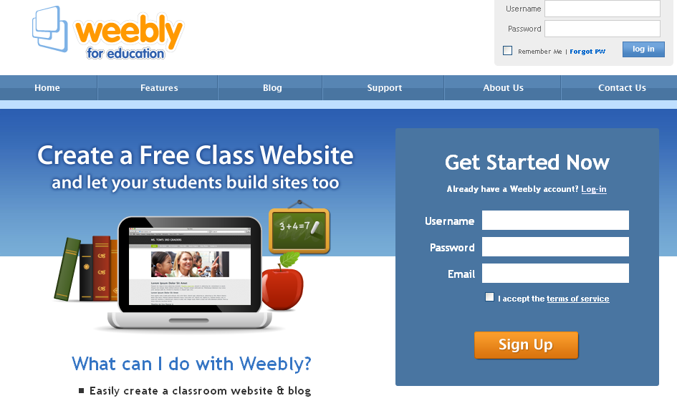

Beginner's Guide to Weebly
The eight articles in this section make up the Beginner's Guide to Weebly. If you're just getting started, we recommend taking time to go through each of these short articles. By the time you're done, you'll be ready to build a great first site.

First Steps
Weebly is the easiest way to build your own website. But that doesn’t mean you can’t use some help getting to know your way around.
All the basics you need in order to put together your first (and second, third, fourth - even seventeenth) site can be found over these next several pages. Take a few minutes to read this guide and you’ll be an expert in about the time it takes to fix a nice breakfast. Maybe one that involves pancakes.
Let's get to it and build a site!

The Site Title
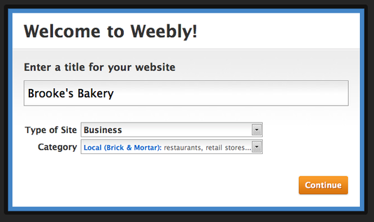

Every site needs to have a title, which is why it's the first thing we ask for when you create a new site. This title can be easily changed later, so don’t worry too much about it here.

The Web Address
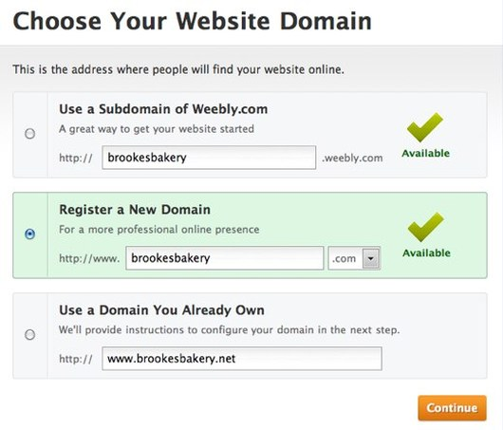
Every site must also have an address (like www.weebly.com for example) so that your visitors can find it. You have three options for choosing an address, and the address, like the title, can be very easily changed at any time:
- Option 1: Use a Subdomain of Weebly.com - This is an address like yoursite.weebly.com. Completely free to use.
- Option 2: Register a New Domain - If you want your own personal domain (like www.amazon.com or www.brookesbakery.com), you can pay to register it with this option.
- Option 3: Use a Domain You Already Own - If you already own a domain that you’ve previously purchased through Weebly or another provider, you can enter it here.

If you’re not sure what you want to do yet, just enter a free sub-domain via Option A.
With these first steps done, your new site should look very similar to the picture below:

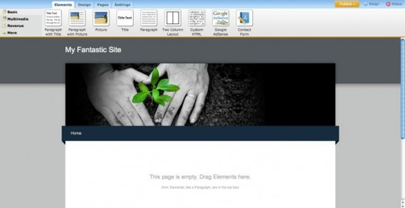

You're now ready to start building your site. In the process of building your site (and reading this guide) you'll be working with:

Elements
Elements are the basic building blocks of your site. All of your site content, be it text, pictures, videos or what have you, is added via an element.

Pages
Your site can have as many pages and sub-pages as you want, since there are no page limits for either free or paid accounts. We’ll be adding several pages (including a blog) to our test site in this guide.

Themes / Design
You can select from any one of a number of themes and switch to a different theme at any time. This affects the look of your site. All of your pages and elements remain in place, no matter what theme you choose. We’ll switch themes and take a close look at the theme options (like changing fonts) towards the end of the guide.

With the basics done, the next step is to learn how to Add Your First Elements to a site.

First Elements: Add Text Your Site
As noted on the previous page, elements are the building blocks of your site. All of your content (aside from a few exceptions like the header image, which we’ll cover later) is added via an element. Let’s explore some of these elements and add them to the first page of our example site.

Text Elements
Adding an element to a site is as simple as clicking on that element and dragging it to the content area of a page. Let's drag the most basic element -- the paragraph element -- to this sample site.

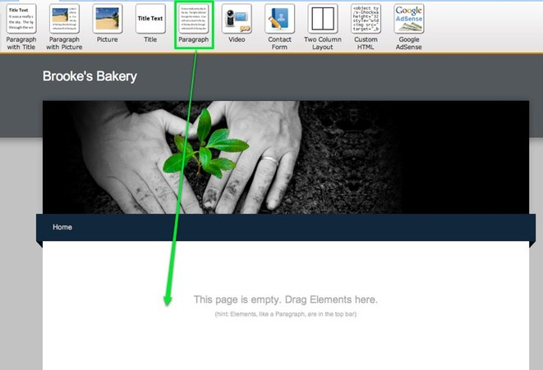

The paragraph element is exactly what it sounds like -- an element for writing text. You can write a word, a sentence or multiple paragraphs in a single element. Just click within the element to start editing.

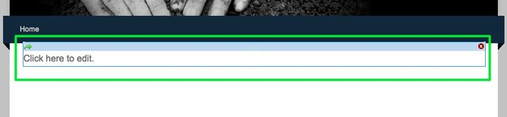
As you write your text, take notice of the blue toolbar at the top of the editor. Every element has its own toolbar with functions specific to that element.

The text toolbar enables you to (from left to right) Bold, Italicize, Underline, change the color, increase the size and decrease the size of selected text. You can also create a link (we'll take a closer look at this a bit later) to another site, a page within your own site, an email address or an uploaded file.
Beyond that you can align all the text in an element to the left, center or right, create both bulleted lists and numbered lists, and also undo / redo changes.
One thing you may notice you can't do is change fonts. That's because the font is controlled through the site's theme and not within individual elements. You can change the default font for different areas of your site via the Design tab, and we'll take a closer look at this a bit later in the guide.
Let's add some text to our example site:

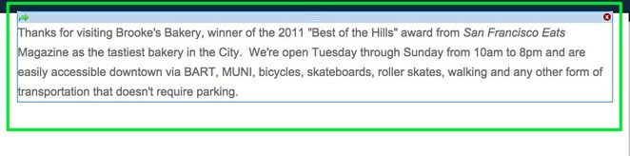
To add more text we could keep writing in this same element, add another paragraph element to the page, or use one of the three other text elements:
- Title - Used for adding titles / headers to a page.
- Paragraph w/ Title - A paragraph element with a spot for title already built in.
- Paragraph w/ Picture - A paragraph element with a spot for both a title and an image built in.
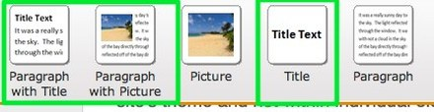

Each of these elements use the same text editing toolbar we looked at above and you can stack as many of them as you want on a page.
Now, how do you add images to the site? Move on to our First Elements: Adding Pictures page to learn more.

First Elements: Add Pictures Your Site
There are four elements that can be used to add images to a site:
The above mentioned paragraph with picture element.
- The picture element -- upload one image per element.
- The picture gallery element -- upload as many pictures as you like to create a gallery of clickable images.
- The slideshow element -- upload as many pictures as you like to create a slideshow of images.
Adding any image element to your site works the same way as adding a text element - just drag it to the page.
Uploading an image to a picture element is as simple as clicking the big blue Sample Image.

This opens a dialog box where you select how you want to upload your image. You can:
- Upload an image from your computer.
- Select one from Flickr's free, searchable library of creative commons licensed images. Using this option will add a small copyright attribution to the footer of your site linking to the photographer who took the image.
- Enter the address of an image from out on the internet. You should only use this third option if you already own the image you're embedding.
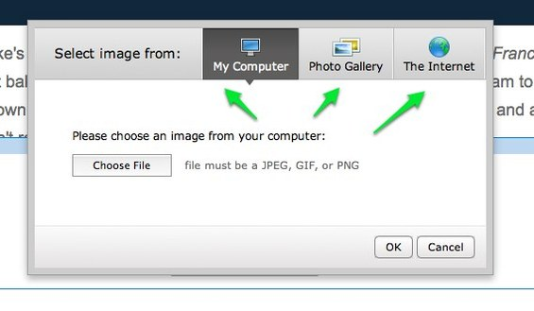

In this example I've selected the My Computer option and then clicked Choose File. Doing so opens a file browser on the computer through which an image can be selected.

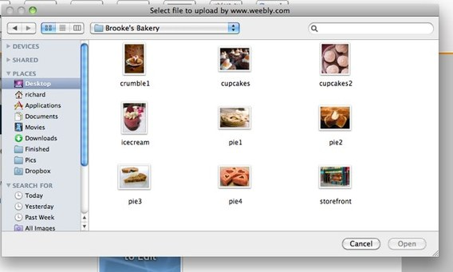
There are a number of different ways to change and edit an uploaded image. The first you'll notice is the the little pop-over menu that appears above the image when you scroll over it. Using this you can:
- Link the image to site, page, email address or file.
- Add a caption to the image.
- Remove the image.
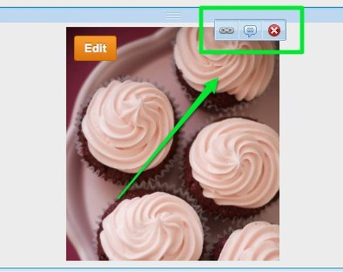

The second is the blue toolbar that appears at the top of the screen when you click directly on the image. Use this toolbar (from left-to-right) to:
- Replace the current image with a new one.
- Set a border size (or no border at all).
- Select a gray or black border
- Position the image to the left / center / right of the element (you can also drag the image within the element to do this).
- Use the Advanced option to set the margins around the image and enter Alt Text if needed (if you don't know what Alt Text is then don't worry about using it).
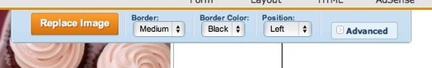

The third is the Edit button that appears in the upper left of the image when you roll over it.

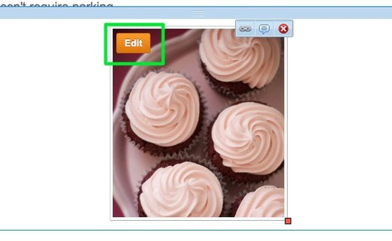
This brings up our ImagePerfect editor. You can use this to crop, rotate and add effects to the image. You can also add more images to this picture element, but this is much more limiting than using our Slideshow or Gallery options.

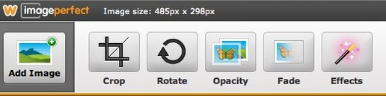
Re-size images by clicking and dragging the box found on the lower-right-corner of each.
And that's the basics of working with an image. If you want to learn specifically how to use a gallery or slideshow, go their respective help pages in this section of our help site to read up on them.
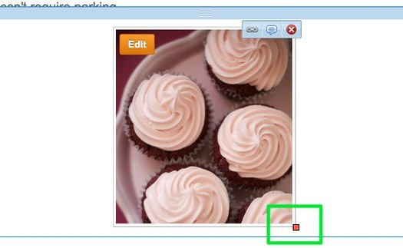
Our site now looks like this:
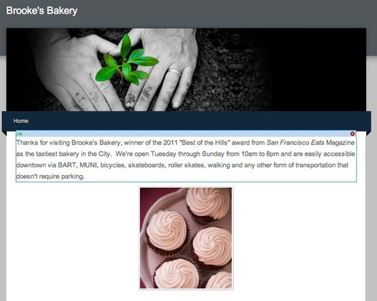

As you can see, each element we've added is stacked above or beneath another element like a column of building blocks. Elements stack on top of one another by default within the editor.
But what if we want to place two or more elements side-by-side? To do that, move on to the next step and learn how to Alter Your Layout.

Alter the Layout of a Page with the

2 Column Element

- By default, the content area of a page allows you only to stack elements one on top of another. No matter how many times you try to drag an element alongside another element, it will always end up above or below that element. This works great, unless you want to line up some of your elements side-by-side in multiple columns. That's where the Two Column Layout comes in.

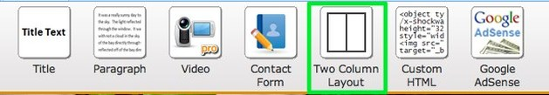

- The Two Column Layout Element works like any other element: just drag it to a page. It will stack above or beneath any other elements you've already placed on that page and is quite literally made up of two empty columns separated by a blue bar.

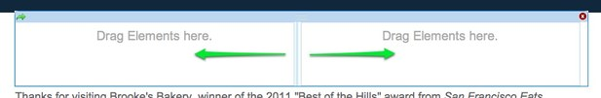

- This blue bar can be clicked and dragged to the right or left to increase / decrease the size of a column. Note that this bar does not appear on your published site, so your beautiful content will not be marred by a blue bar running down the middle.
Adding content to one of the columns is as simple as dragging that content into the column.

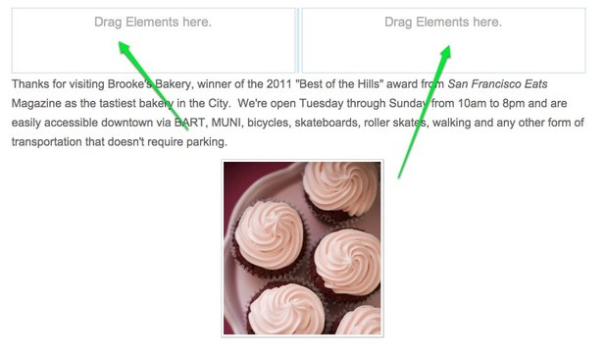

- Moving an element is as simple clicking and then dragging on the blue bar at the top of the element.

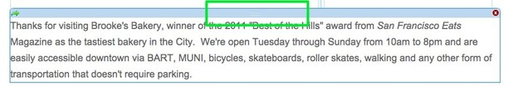
- The text and image content we uploaded earlier has now been placed into the two column element.

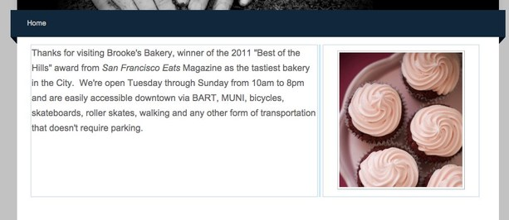

- A column can contain more than just one element -- you can put as many elements as you like in each column. You can also place other elements above or below the two-column layout. Give it a try!

Create More Pages for Your Site
Whether you're a free user or a subscriber to our Pro service, your site can have as many pages and sub-pages as needed. We place no limits whatsoever on the number of pages that can be added to a site. Creating a new page is as simple as going to the Pages tab and clicking the Add Page button.
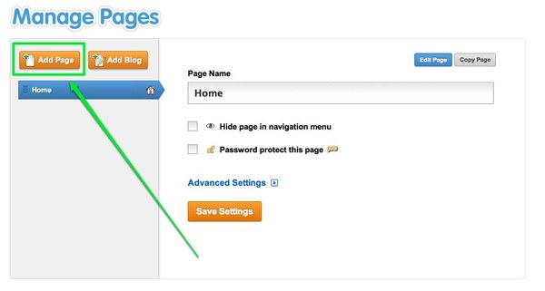
There is an option to Add a Page or Add a Blog. For now let's focus on just creating New Pages.
Clicking the Add Page button adds a new page to your list.

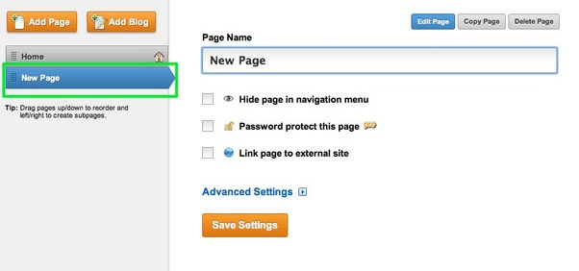

Working from top-to-bottom you can:
- Edit the Page (which will take you back to the elements area of the editor that we've previously been looking at)
- Copy the Page to use as the basis for a new page
- Delete the Page
- Change the Page's name
- Hide the Page from the Navigation Menu . If this is unchecked the page is accessible via the site's navigation. If the box is checked then the page is hidden from the navigation (though you can easily create your own links to hidden pages)
- Password Protect this Page, which requires a subscription to our Pro service
- Link Page to an External Site (creating a navigation link that leads to another site entirely).
- Adjust the Advanced Settings.

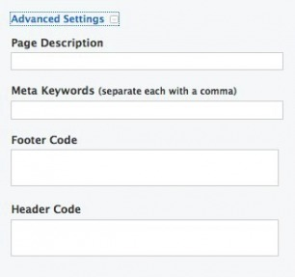
The Advanced Settings for each page are useful for improving your site's Search Engine Optimization. If you don't know what this is, just ignore it for now. You can learn more about SEO via the appropriate section of our help site (once you're more familiar with putting a site together).
Let's add several new pages to the example site (clicking Add Page again will add another page and save the changes to the page you were working on): a page for Sweet baked goods, a page for Savory bakes, an about Our Chefs a page, a Write Us page for a contact form, a Visit Our Shop page to provide the address, directions and a map.

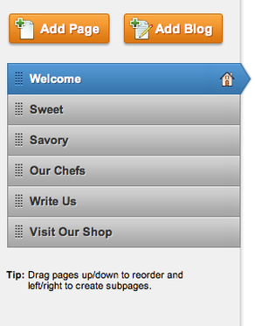

You can re-arrange the order of the pages by clicking and dragging them up and down the list. Dragging a page to the top of the list will make that page your Home, which is indicated by the house icon to the far right of the page name. The Home page can have whatever name you want it to have -- the name for this site's Home has been changed to Welcome.
Let's create a sub-page by dragging the Write Us page underneath and to the right of the Visit Our Shop page. Sub-pages appear in the site navigation menu as part of a drop-down menu for whatever page they're connected to (well see how this looks in a moment).
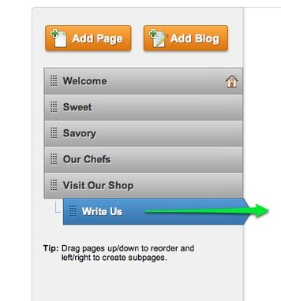

To create a sub-pages, just drag one page underneath another page and then drag it to the right until you see each one connected to the main page via a dotted line. You can have as many sub-pages of a main page as you want.
Now the navigation menu for our sample site (which previously just showed a link to Home) includes links to all the pages we created.

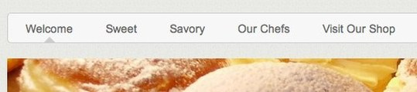

And if we scroll over the Portfolio link with the mouse pointer, a drop-down menu appears with a link to each of the sub-pages we created.

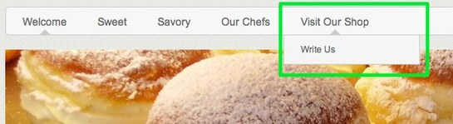

To edit the content of a page just click on its link from the navigation menu or go to the Pages tab, select the page from the list and click the Edit Page button.

- Now that we've setup a basic home page, let's make some changes to our theme.

Switch Themes and Edit Fonts

- Now that our site is coming along, this seems like a good time to decide which theme to use for the design. A theme can be selected at any time (whether at the beginning, middle or end of the process of creating the site) and selecting a new theme does not delete or alter the content of your site.
- To change your theme, go to the Design tab:

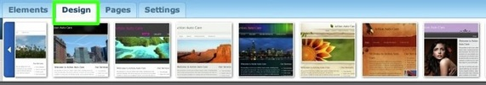
- The first thing you see here is the "Favorites" section, where we display a number of our favorite themes. This is also where your own favorite themes will appear when you select them.

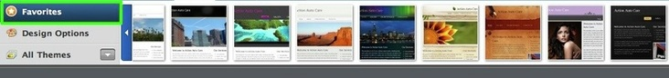

- If you scroll over a theme in the favorites area, you'll see how your own site will look if you select that theme. If you scroll off of the theme, you'll see the original theme again. To select a theme, click on it.
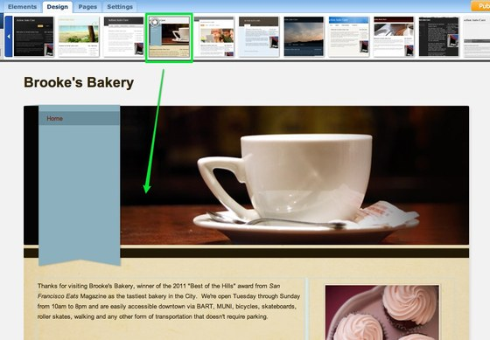

- If you go to the All Themes section of the the Design tab, you'll see all the themes. These can be viewed as one big group or by looking through different categories like Business or Wedding. Don't feel constrained by the categories - any theme can be used by any person or business to create a nice looking site.
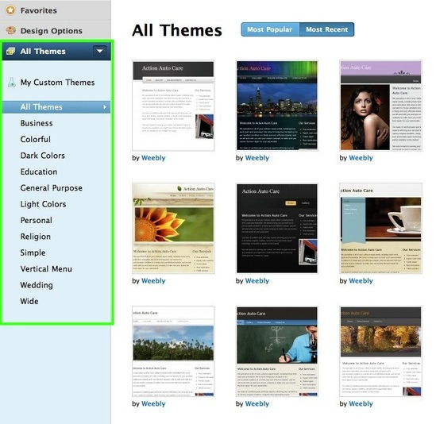

- When you see a theme you like, scroll over it and click the Preview button to see how your own site looks with this theme.
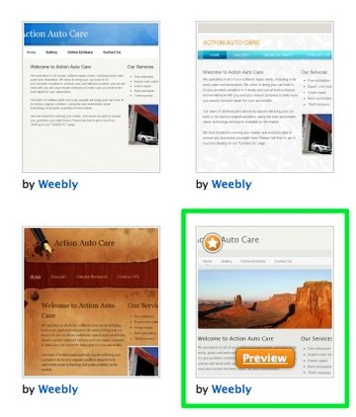
- Here's how our example site looks with the theme we've selected to preview.

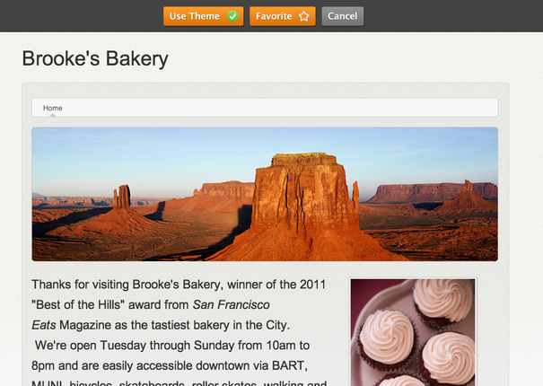

- Click Use Theme to use the theme for your site, click Favorite to add it to your Favorites list or click Cancel to look through more themes.

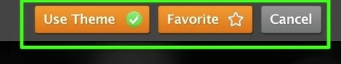

- After you select a theme, use the Design Options section to set the default fonts for that theme.
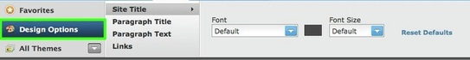

- You can alter the fonts for your Site Title, Paragraph Titles, Paragraph Text (this is most of the text on your site) and for your Links.
We have roughly one hundred different fonts to choose from. Let's use Josefin Sans Std for this site.

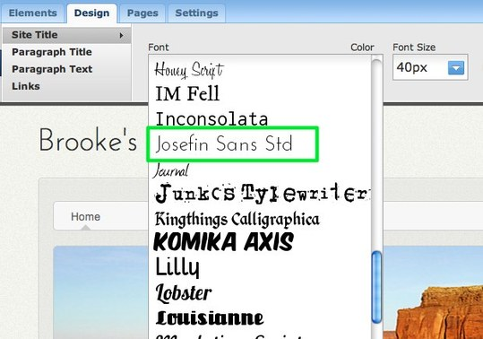

With a new theme and font chosen, let's look at how to Edit a Theme's Header Image.

Edit the Header
A lot of our themes include an area for a header image (you'll know your theme includes this if there's a default image at the top of theme). As it's doubtful you'll want to use the default image on any of your pages, we've built an easy to use header creation tool called ImagePerfect so you can make your own header.
Note that if your theme does not have a default header image, you won't be able to use this feature unless you select another theme.
To get started, scroll over the header image and click the Edit Image button:
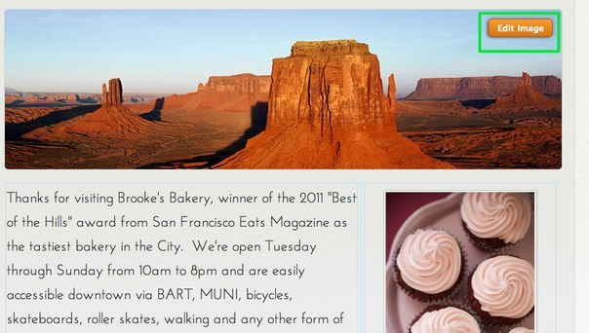

After you do this, you'll probably want to go ahead and delete the default image. Click the image and then click the red X in the corner to do so.
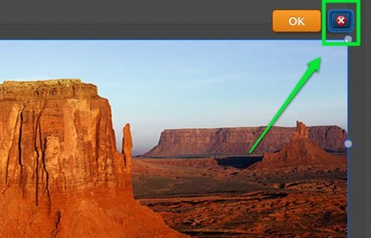

To add an image to the header, click the Add Image button in the upper right.

This gives you the option to select your own image...
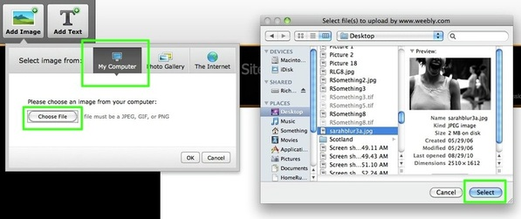
Or to choose a Creative Commons licensed photo from Flickr. You can use the provided field to search for an appropriate image for your site.

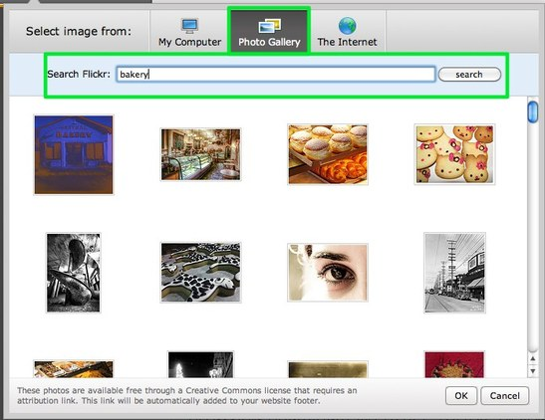

Once you upload or select an image, you can edit it. This image is too big for the header of the page.

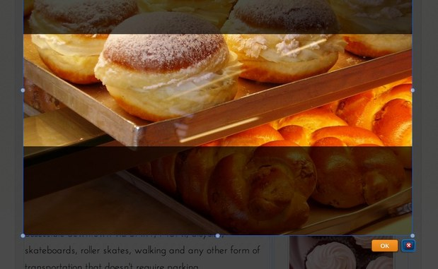
Images can be re-sized using the little bubbles at each corner and side of the image.

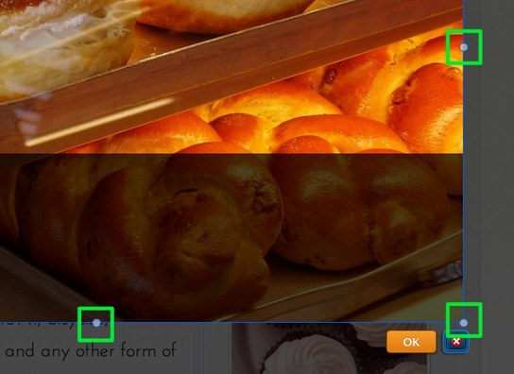

And an image can be dragged by clicking anywhere on it and dragging it.

Use the provided tools at the top of the page to edit and add text / effects to the image as needed.

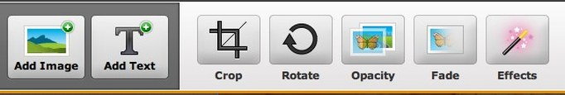

When you're happy with an image, select the Save button to Save it. You can use the arrow to the right of the Save button to choose whether to save the image to every page of the site, just this page or to select only certain pages to save it to. In that way you can have different headers on different pages if you want.

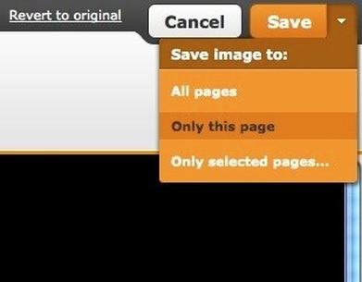

And here's how the page looks with the Saved image. You can scroll back over a Saved header to edit it some more.

Keep in mind that multiple images can be added to the same header just by continuing to add images using the Add Image button.
With this done, let's move on and Add More Pages to the site.

Start a New Blog

- To create a blog, go to the Pages tab of the editor and click the New Blog button.
- 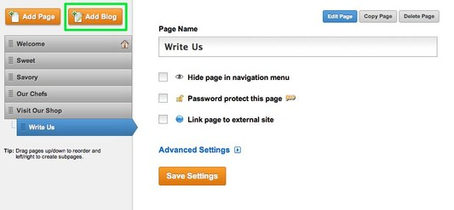
- This will add the blog to your list of pages.

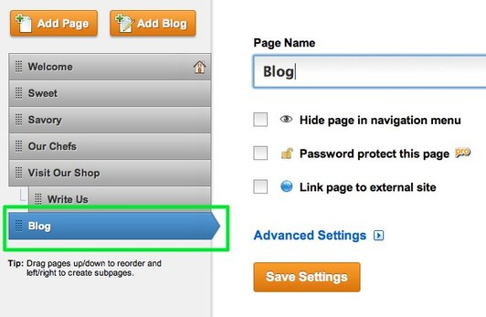

- Give the blog a name and then click Edit Page to start adding content.
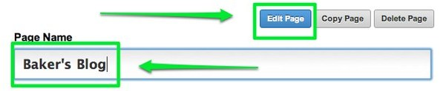

- A new blog starts with a sample post (that you can either edit or delete) and a sidebar with some default content that you can easily change.
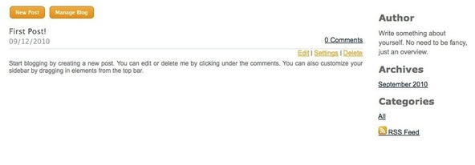

- To create a new post for your blog, use the New Post button at the top of the blog itself.
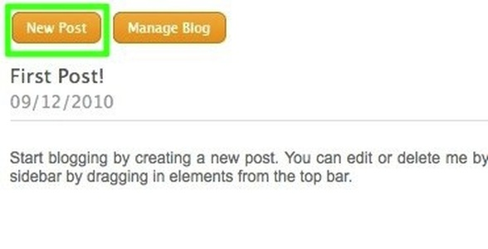

- Your blog post has a title and a content area. The title should generally be short - no more than a sentence long or so. The content area includes a basic paragraph element which you can either edit or delete.

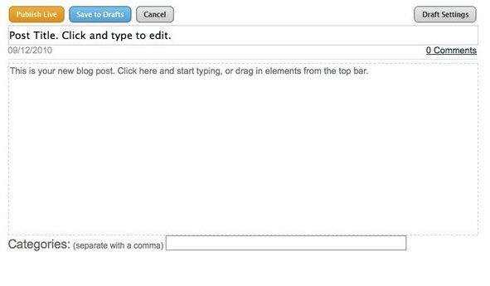
- Adding content to a blog post works the same way as adding content to a regular page - just drag elements into the post and edit them to add content.

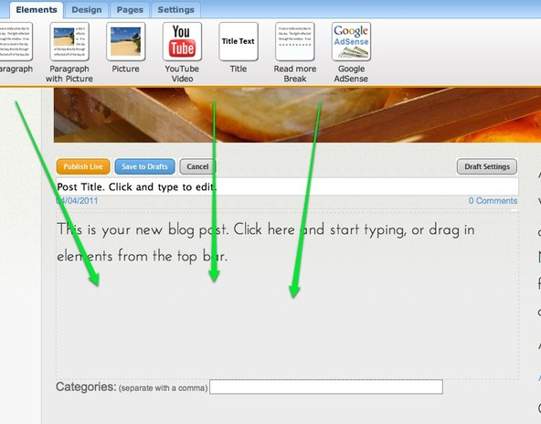

- Once you've added your content you can categorize the post - these categories will appear on your sidebar, making it easier for visitors to your blog to find posts that cover certain topics. Categories can be whatever you like and it isn't necessary to use them.

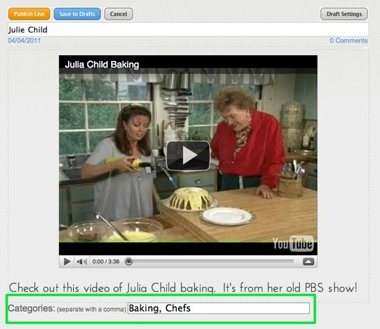

- Now you can Publish the post to your live site (which will make it instantly available) or Save to Drafts to edit / publish it later.

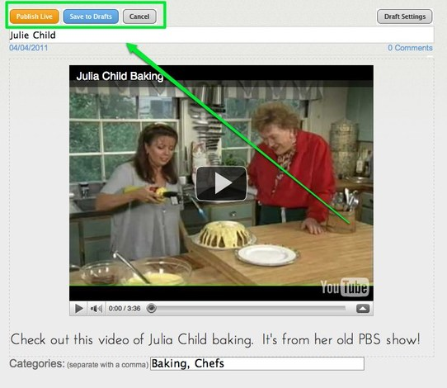

- If you save the post as a draft, it'll be accessible to you through a drafts area at the top of the blog page from within the editor (along with any other drafts you've saved). Just click the link to the post from this drafts area to edit it further and Save / Publish.

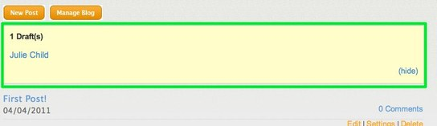

- Every new post you Publish will appear at the very top of the page, pushing older posts further down the page. After you've added seven or eight posts to the page, older posts will be moved off the main page to still accessible archive pages.
Now that you've learned the basics, Publish Your Site and Next Steps

Publish Your Site and Next Steps

- Now that you've added some basic content to your site, this is a good time Publish it. To do so, just use the Publish button in the upper right corner of the editor.

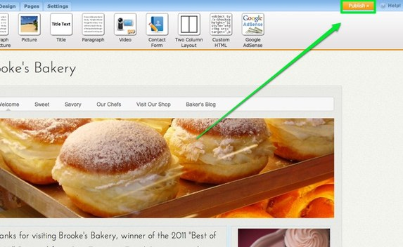

- This will bring up a verification box, letting you know your site has been Published.
You can click the Published address to view your site (you can also give this address out so that other people can use it to visit your site), use the Facebook and Twitter buttons to link your friends and followers at either provider to your site, and click the "x" in the corner of the box to close the box and continue editing your site.

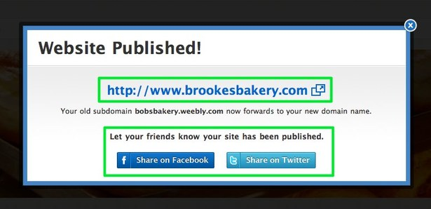

- Of course, you are probably not done with your site at this point, and that's OK. You can continue to add content through the editor whenever you like and then click the Publish button to push that content to your live site. You can also unpublish your site (if needs be) by going to Settings > Unpublish.

Upload an Image
To upload a single image, use our Picture element. This element can be found under the Basic tab. Drag it to a page to get started.

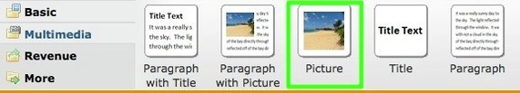

Then click the Sample Image.

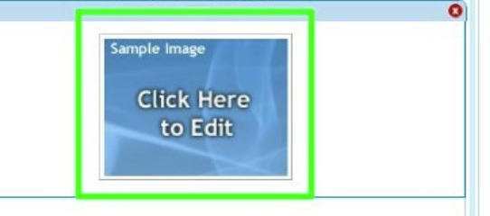

This will open a dialog box that presents you with four different image options. Stick with the one right in front of you and click the big green button. From here you can select the image you want to upload.

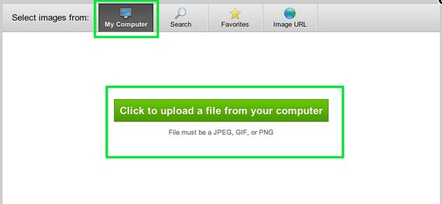

Images post to the page in varying sizes (usually they post at the full width of the content area of the site), but you can make any image larger or smaller using the re-size box in the lower-right corner of the image. Re-sizing an image will not impact its quality. And note that you cannot make an image larger than the content area of the site itself.

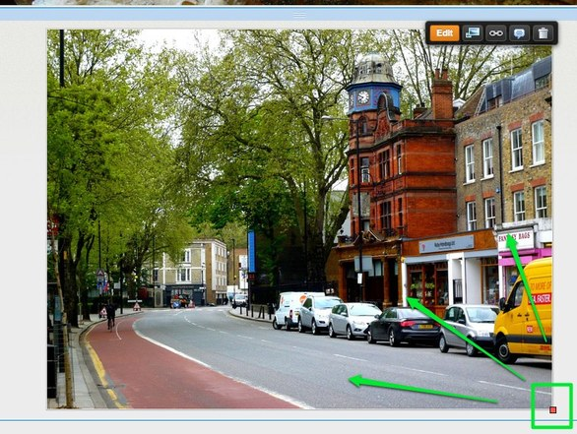

You can click an uploaded image to make further changes to it. Use the options in the upper right to add a basic caption, turn the image into a link, link the image to a larger version of itself or edit the photo using our ImagePerfect tools.
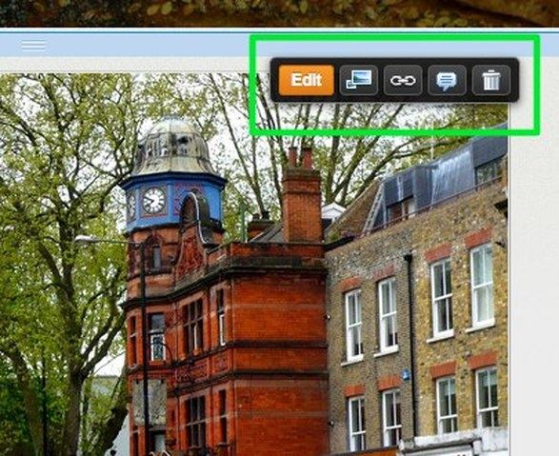
And use the toolbar above the image to select whether you want a border, if you'd like that border to be gray or black, where you'd like the image positioned within the element (you can also drag the image to position it), and use Advanced to alter the margins of the image and set Alt-Text if needed.

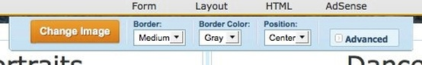

Create an Image Slideshow
Our slideshow element (available under the "Multimedia" category of elements) enables you to show off your photos with style. Learn how to use it in less than three minutes by following along with the short video below or by reading the illustrated instructions that follow.
To add a slidehow, just drag the element to a page on your site.

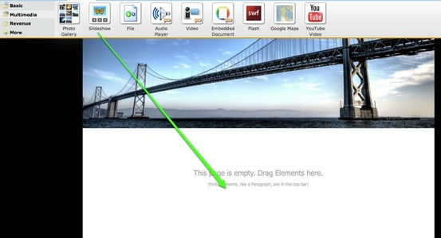
This will open the "Choose a Slideshow Style" dialog box where you can select which style of slideshow you want. This can always be changed later (we even provide more options later), so don't spend too much time worrying about which one you want. Let's select Thumbnails on Bottom for this example.

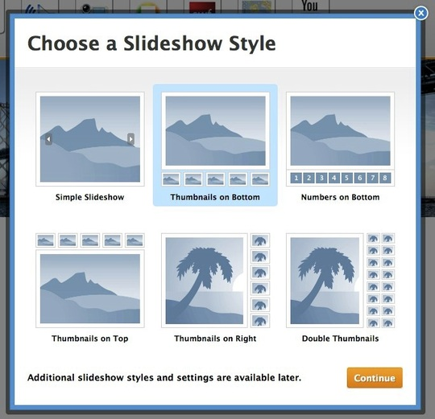

You'll now be prompted to upload photos. Hit the big Upload Photos button to get started.

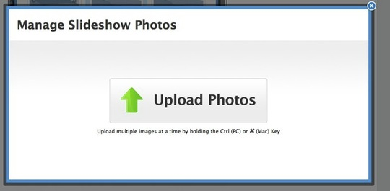

Then select the photos you want to upload. You can always delete photos / upload more later.

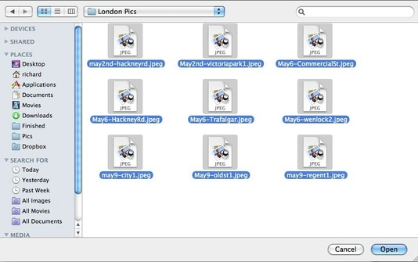

Depending on how many photos you selected, it may take them a few minutes to upload. Once they're done uploading you'll see them all on the photo management screen.
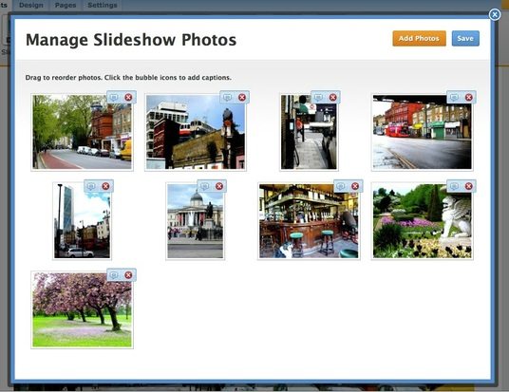

You can drag photos to re-order them, click the "x" next to each to delete them and click the "bubble" icon to add a caption that'll appear along with the photo in the slideshow.

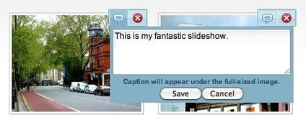

When you're ready to move on, click Save and you'll new see the slideshow as part of the page.

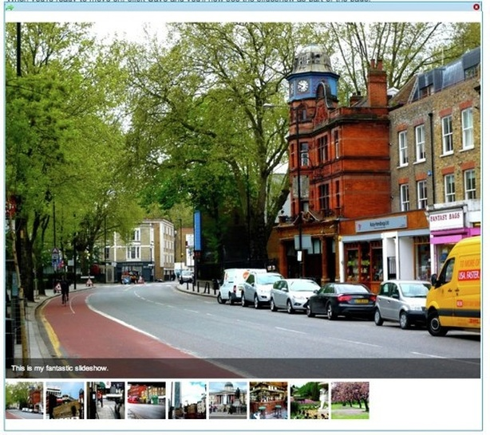

You can now use the slideshow toolbar to make changes.
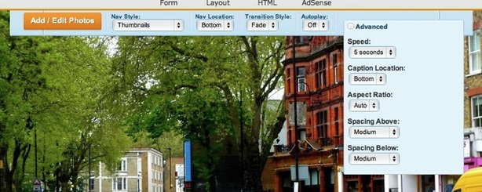
- Use the Add / Edit Photos button to bring up the Manage Photos dialog box we saw earlier.
- Use Nav Style to select whether you want to use Thumbnails, Numbers or neither.
- Use Nav Location to place the Nav Bar at the Bottom, Top, Left or Right of the slideshow.
- Select Fade or Slide for the Transition Style. This determines how the show moves from one image to the next.
- Turn Autoplay Off / On for the show. If it's on, then the slideshow will immediately start playing when a visitor opens the page.
- And with the Advanced option, set the speed of the show (how long each image is shown), whether you want the Captions (if you have any) on the top or bottom and what you'd like the Aspect Ratio to be (16:9, 4:3, or 3:2). The system is very good about determining this automatically, though.
Note that the slideshow will automatically expand to the width of the page or column in which you've placed it.
Check out the slideshow below to see how it usually works. This slideshow has the navigation and captions set to the bottom of the show and auto-play is turned off.
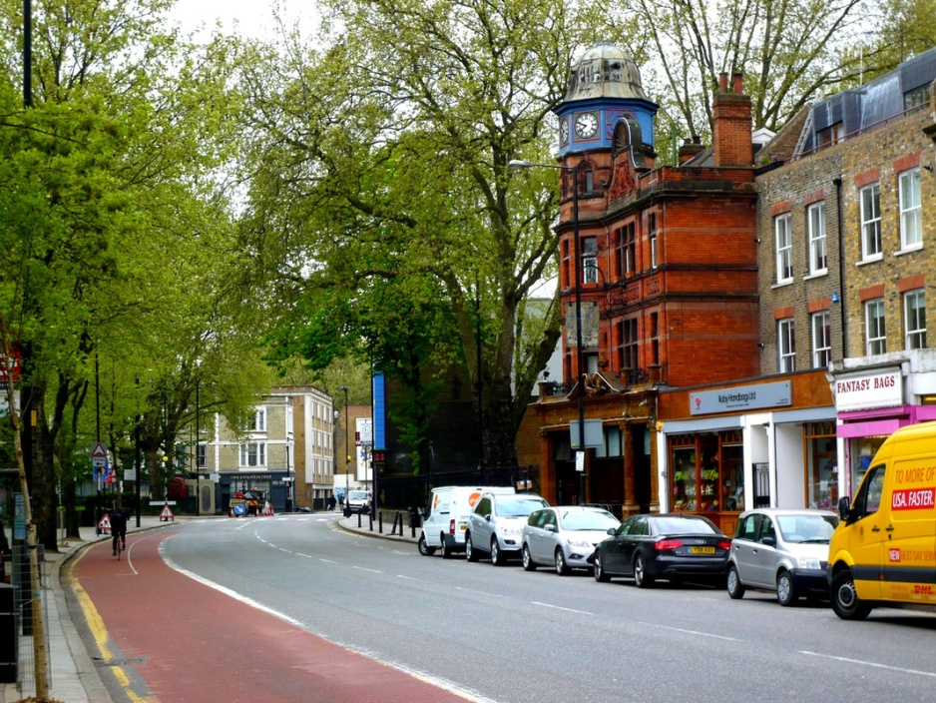

This is my fantastic slideshow.

- Video & Audio
- Pages
- Blogs & Forums
- Forms & Surveys
- Site Headers
- Widgets & Other Content
- E-Commerce & Ads
- Stats & SEO
- Live Training

